# Data Structures and Algorithms

In class Lab 09

Index-210670N

Github Repo link- <https://github.com/OmalyaV/In-class-lab>

Section 1

**Task 1**

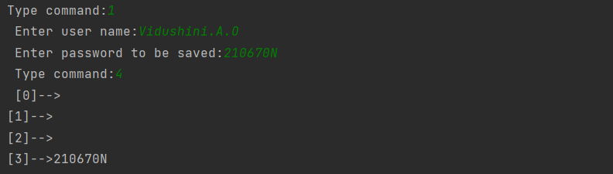

Task2

**Task 3**

* With this kind of simple hash table the collisions are not managed, therefore, when the hash function generates the same hash codes for two passwords the second password cannot be stored in the hash table.

To prevent this, we need to use techniques like chaining, linear probing or quadratic probing to manage collisions and store even the colliding data in the hash table.

Section 2

**Task 1**

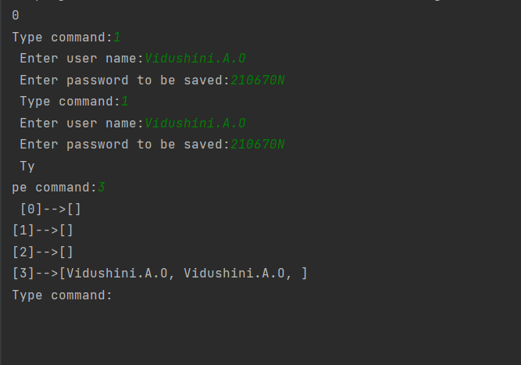

Task 2

